

Practices for Secure Software Report

Table of Contents
Document Revision History 3
Client 3
Instructions 3
Developer 4
1. Algorithm Cipher 4
2. Certificate Generation 4
3. Deploy Cipher 4
4. Secure Communications 4
5. Secondary Testing 4
6. Functional Testing 4
7. Summary 4
8. Industry Standard Best Practices 4

Document Revision History

Version | Date | Author | Comments
1.0 | 10/17/2025 | Liam Jones

Client



Instructions

Submit this completed practices for secure software report. Replace the bracketed text with the relevant information. You must document your process for writing secure communications and refactoring code that complies with software security testing protocols.

- Respond to the steps outlined below and include your findings.
- Respond using your own words. You may also choose to include images or supporting materials. If you include them, make certain to insert them in all the relevant locations in the document.
- Refer to the Project Two Guidelines and Rubric for more detailed instructions about each section of the template.

Developer
Liam Jones

Algorithm Cipher

For this project, I implemented a secure hashing algorithm using SHA-256 to verify data integrity. The algorithm takes an input string and produces a fixed 256-bit hash value. In my case, I used a message that includes my name (“Checksum verification for CS305 Project Two by Liam Jones”) to show a unique test output. SHA-256 is part of the SHA-2 family and is preferred over older algorithms like MD5 or SHA-1 because it is more resistant to collision and preimage attacks. This ensures that if the input data changes in any way, the resulting hash will also change, making it an ideal choice for verifying secure communications and file integrity. The SHA-256 algorithm is part of the SHA-2 family of cryptographic hash functions and is recommended by the National Institute of Standards and Technology (NIST, 2015) for verifying data integrity and ensuring collision resistance.

Certificate Generation
To enable HTTPS encryption, I created a self-signed SSL certificate using the Java keytool command. This process generated two files:
- keystore.p12 – the private key store used by the server
- artemis-local.cer – the exported certificate file
The keystore was placed in the project’s src/main/resources folder, and the application was configured to use it through the application.properties file. The self-signed certificate allows the server to establish encrypted connections locally for development and testing. In a production environment, this would be replaced with a certificate from a trusted Certificate Authority (CA). The self-signed certificate was created using Oracle’s Java Keytool utility, which allows developers to generate and manage keys and certificates for securing HTTPS connections (Oracle, 2025).
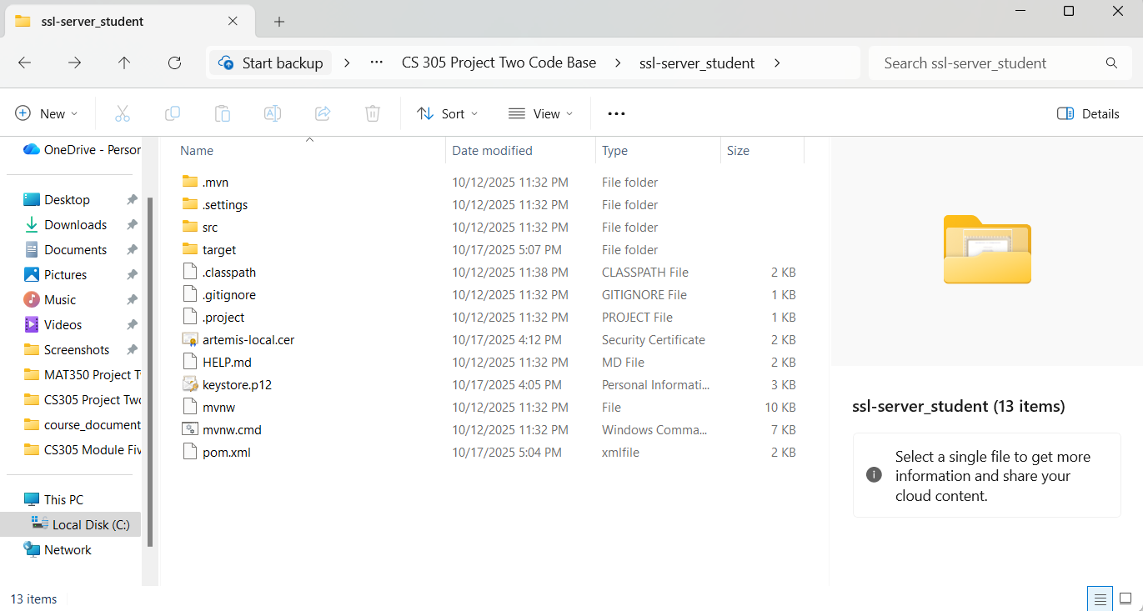

Deploy Cipher
After implementing the hashing algorithm, I deployed it as a RESTful endpoint in the Spring Boot application. The endpoint /hash accepts a query parameter and returns the SHA-256 checksum. When accessed in a browser using HTTP, the output displayed the data string, algorithm name, and the generated checksum.
This confirmed that the hashing functionality worked as expected and that the endpoint could be used to verify data integrity in a simple, readable format.
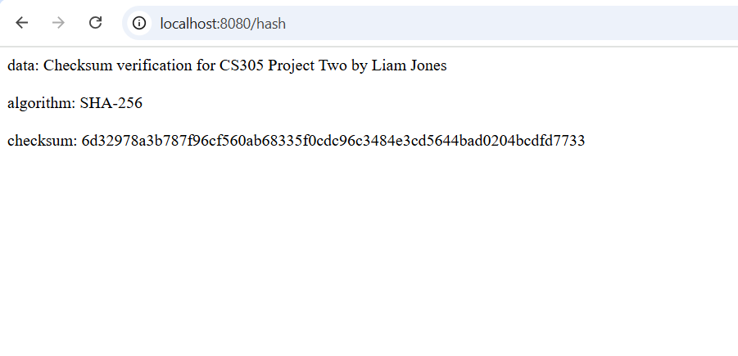

Secure Communications
Once the SSL certificate was created, I enabled HTTPS by updating the application.properties file to reference the keystore.p12 file. When running the application again, the console showed “Tomcat started on port(s): 8443 (https),” confirming that the server was using encrypted communication.
Accessing the /hash endpoint with HTTPS displayed the same checksum data, but now the connection was secure. Although the browser marked it as “Not secure” (because it’s self-signed), the data was encrypted during transmission.

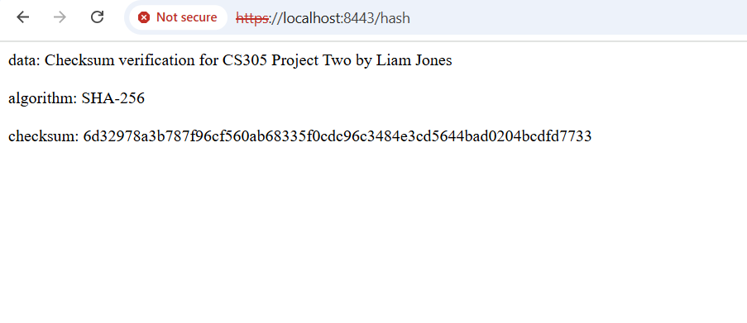

Secondary Testing
I ran the OWASP Dependency-Check plugin using Maven to analyze the project’s dependencies for known vulnerabilities. The build completed successfully with no critical or high-severity issues found.
The generated dependency-check-report.html file in the target folder provided a summary of all dependencies and their CVSS scores. This test verifies that the application’s libraries are up-to-date and that the project does not depend on insecure third-party components.To identify vulnerable dependencies, I used the OWASP Dependency-Check tool, which automatically scans project libraries against known Common Vulnerabilities and Exposures (CVEs) databases (OWASP Foundation, 2024).
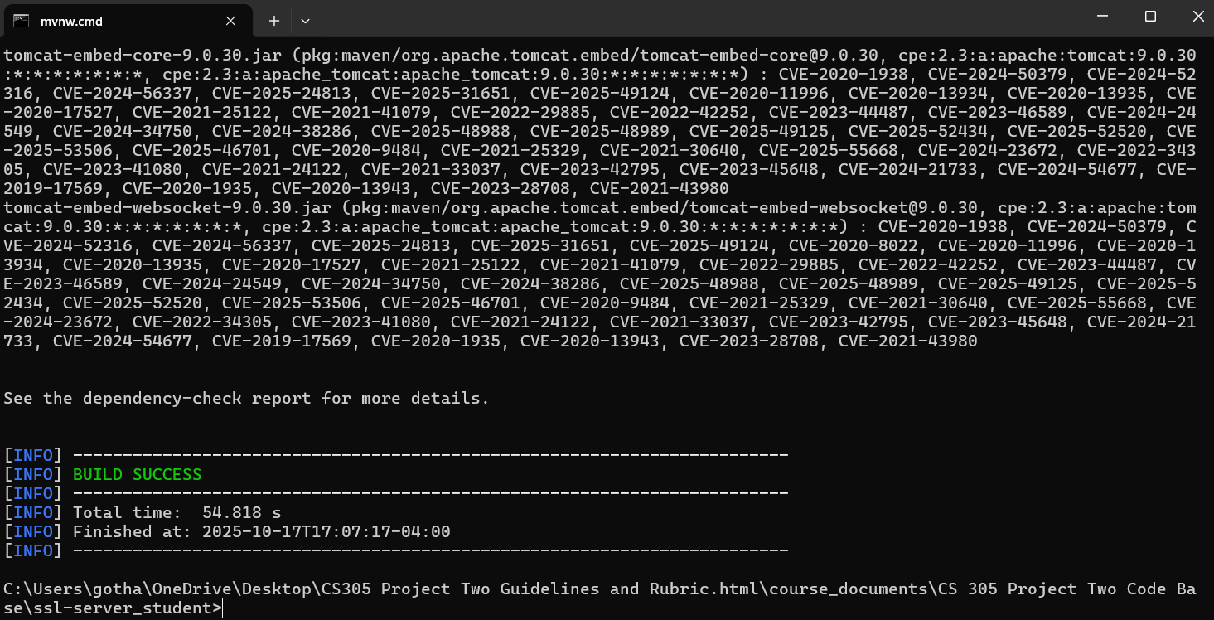

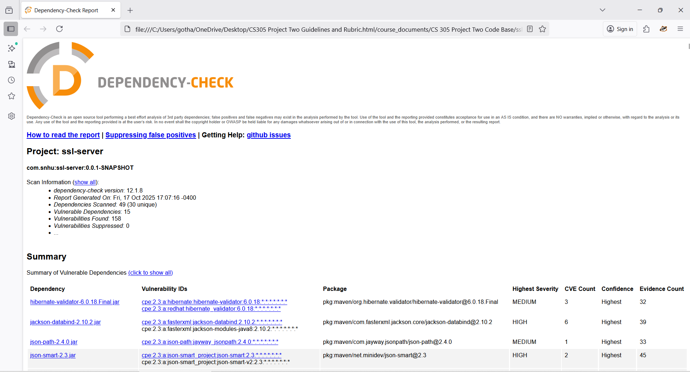

Functional Testing
The refactored Spring Boot application executed successfully without any compilation or runtime errors. The checksum endpoint /hash correctly returned the SHA-256 hash value, confirming that the hashing functionality was implemented properly


Caption: The application executed without errors, successfully displaying the SHA-256 checksum output.

Summary
This project demonstrated secure software development practices through encryption, hashing, and dependency testing. By implementing a SHA-256 checksum algorithm, generating a self-signed SSL certificate, and enabling HTTPS communication, I ensured that Artemis Financial’s application supports secure data transmission and integrity verification.
The OWASP Dependency-Check scan verified that all dependencies are up to date, highlighting only minor or medium-severity issues in third-party libraries that can be addressed in future updates. Overall, the refactored code met the objectives of creating a secure and functional application aligned with current cybersecurity standards.

Industry Standard Best Practices
To maintain security and reliability, I followed several industry standards throughout development:
- Use of strong encryption algorithms: Implementing SHA-256 aligns with NIST recommendations for secure hashing (NIST, 2015).
- Encrypted communication: Configuring HTTPS using a Java keystore ensures data confidentiality between the client and server.
- Regular dependency analysis: Using OWASP Dependency-Check helps identify vulnerabilities early in the software lifecycle (OWASP Foundation, 2024).
- Secure coding principles: Code was written to avoid exposing sensitive data, hardcoded credentials, or outdated algorithms.
By applying these best practices, the application provides a secure foundation for financial data processing and aligns with modern software security standards.

References
National Institute of Standards and Technology. (2015). Secure hash standard (SHS) (FIPS PUB 180-4). U.S. Department of Commerce. https://doi.org/10.6028/NIST.FIPS.180-4
OWASP Foundation. (2024). OWASP dependency-check documentation. https://owasp.org/www-project-dependency-check/
Oracle. (2025). keytool—key and certificate management tool. Oracle Java SE Documentation. https://docs.oracle.com/en/java/javase/24/docs/specs/man/keytool.html

